**A**

**PROJECT REPORT ON**

**“TRAVIO.”**

Submitted in partial fulfilment of requirements for the award of degree of

**BACHELOR OF TECHNOLOGY**

in

**Computer Engineering**

by

|  |  |
| --- | --- |
| **PARIMAL R. CHAUDHARY** | **T2010121245025** |
| **SIDDHANT B. JAGTAP** | **T2010121245056** |
| **SAHIL P. GUDAPE** | **T2010121245060** |

Under the Guidance of

**Prof. Jaya Zade**

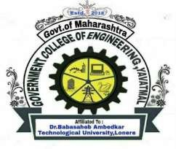

Department of Computer Engineering

Government College of Engineering, Yavatmal

2022-2023

Department of Computer Engineering

Government College of Engineering, Yavatmal

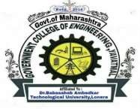(An Institute of Government of Maharashtra)

***CERTIFICATE***

This is to certify that the Mini Project report entitled

**“TRAVIO.”**

is a bonafide project work and has been carried out by team:

|  |  |
| --- | --- |
| **PARIMAL R. CHAUDHARY** | **T2010121245025** |
| **SIDDHANT B. JAGTAP** | **T2010121245056** |
| **SAHIL P. GUDAPE** | **T2010121245060** |

of Third Year B-Tech class under the guidance of Prof. Jaya Zade during the academic year 2022 -2023 (Sem-VI).

|  |  |  |
| --- | --- | --- |
| Prof. Jaya Zade  **Project Guide** |  | Prof. C. V. Andhare  **Head, Computer Department** |
|  |  |  |
| Dr. P. M. Khodke  **Principal** | | |

Department of Computer Engineering

Government College of Engineering, Yavatmal

****(An Institute of Government of Maharashtra)

This is to certify that the Mini Project report entitled

**“TRAVIO.”**

is a bonafide Mini Project work submitted by:

|  |  |
| --- | --- |
| **PARIMAL R. CHAUDHARY** | **T2010121245025** |
| **SIDDHANT B. JAGTAP** | **T2010121245056** |
| **SAHIL P. GUDAPE** | **T2010121245060** |

in partial fulfilment for the award of degree of bachelor of technology in Computer Engineering.

|  |  |  |
| --- | --- | --- |
| Prof. Jaya Zade  **Project Guide** |  | Prof. C. V. Andhare  **Head, Computer Department** |
|  |  |  |
| **Internal Examiner** |  | **External Examiner** | |